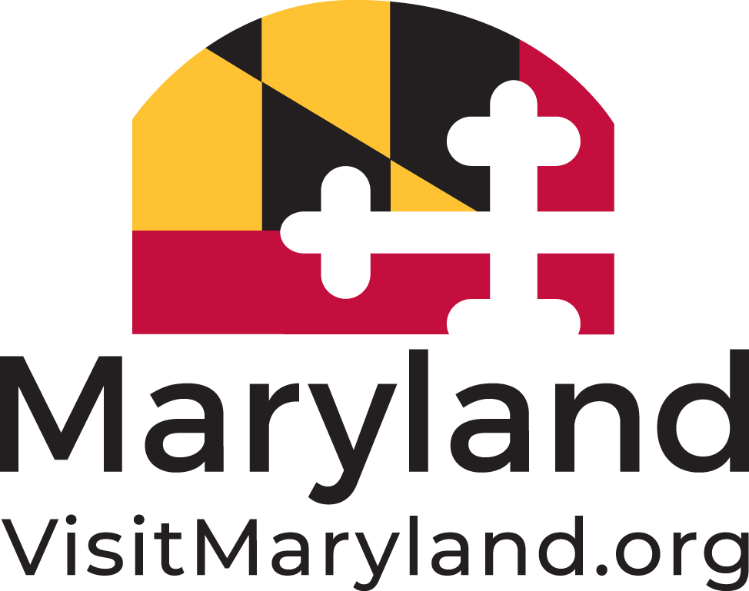

2024 MARYLAND TOURISM AWARDS

LEVERAGING PARTNERSHIPS
NOMINATION FORM

Note: Eligible nominations will include partners (financially vested) and/or allies (non-financial and/or in kind), to identify and package complementary assets (i.e., trails that exist in each partner’s territory, by-ways that pass by a hotel/restaurant/shopping district, etc.) to drive revenue by generating overnight stays.
Nominee Information:
Nomination Name:
Contact Name:
Mailing Address:
City/State: Zip:
Phone number:
E-mail:

Nominator Information (if different than above):
Name of Nominator:
Organization:
Mailing Address:
City/State: Zip:
Phone number:
Email:

NOTE: Please limit the information provided per description to 200 words or less and include quantifiable results when applicable.

- Results – goal driven, quantifiable outcomes (i.e., increased visitation, increased generated revenue, visitor satisfaction) - 40%

- Strategic Approach – goals and roles (including product development, marketing activities, programming and/or events) of each partner in achieving those goals - 30%

- Need for the partnership and rationale of each partner’s participation - 15%

- Creativity, uniqueness of the partnership and significance to each partner - 15%

