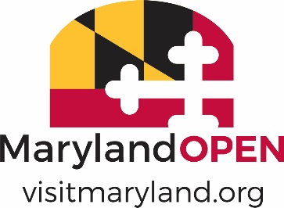

2022 MARYLAND TOURISM AWARDS

TRANSACTIONAL OPPORTUNITIES
NOMINATION FORM

Note: Eligible nominations will have created programming (hotel driven, motor coach/boat/air/land tours and/or convention/event complexes) that makes the cash register ring, and have steadily grown from the beginning of the program.
Nominee Information:
Nomination Name:
Contact Name:
Mailing Address:
City/State: Zip:
Phone number:
E-mail:

Nominator Information (if different than above):
Name of Nominator:
Organization:
Mailing Address:
City/State: Zip:
Phone number:
Email:

NOTE: Please limit the information provided per description to 200 words or less and include quantifiable results when applicable.

- Net amount of revenue generated/increased - 40%

- Strategic Approach (goals and roles) – 25%

- Sustainability of campaign - 25%

- Creativity and ingenuity - 10%

