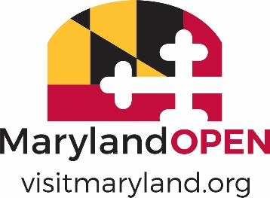

**2022 MARYLAND TOURISM AWARDS**

**LEVERAGING PARTNERSHIPS**

**NOMINATION FORM**

**Note: Eligible nominations will include partners (financially vested) and/or allies (non-financial and/or in kind), to identify and package complimentary assets (i.e., trails that exist in each partner’s territory, by-ways that pass by a hotel/restaurant/shopping district, etc.) to drive revenue by generating overnight stays.**

**Nominee Information:**

|  |
| --- |
| **Nomination Name:** |
| **Contact Name:** |
| **Mailing Address:** |
| **City/State:** **Zip:** |
| **Phone number:** |
| **E-mail:** |

**Nominator Information (if different than above):**

|  |
| --- |
| **Name of Nominator:** |
| **Organization:** |
| **Mailing Address**: |
| **City/State:** **Zip:** |
| **Phone number:** |
| **Email:** |

**NOTE: Please limit the information provided per description to 200 words or less and include quantifiable results when applicable.**

* Results – goal driven, quantifiable outcomes (i.e., increased visitation, increased generated revenue, visitor satisfaction) - 40%

* Strategic Approach – goals and roles (including product development, marketing activities, programming and/or events) of each partner in achieving those goals - 30%
* Need for the partnership and rationale of each partner’s participation - 15%
* Creativity, uniqueness of the partnership and significance to each partner - 15%