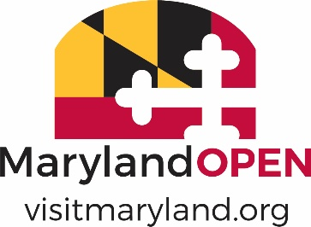

2022 MARYLAND TOURISM AWARDS

MAXIMIZING OPPORTUNITIES
NOMINATION FORM

Note: Eligible nominations must successfully take advantage of an event, trend or asset (including events, anniversary celebrations, promotions or advertising campaigns) to generate overnight stays and increase the number of visitors and/or customer base over the previous year(s).
Nominee Information:
Nomination Name:
Contact Name:
Mailing Address:
City/State: Zip:
Phone number:
E-mail:

Nominator Information (if different than above):
Name of Nominator:
Organization:
Mailing Address:
City/State: Zip:
Phone number:
Email:

NOTE: Please limit the information provided per description to 200 words or less and include quantifiable results when applicable.

- Creativity of the program – 25%

- Percentage amount increase over previous years (40%)

- ROI (investment as it relates to increased attendance/visitor spend) (35%)

