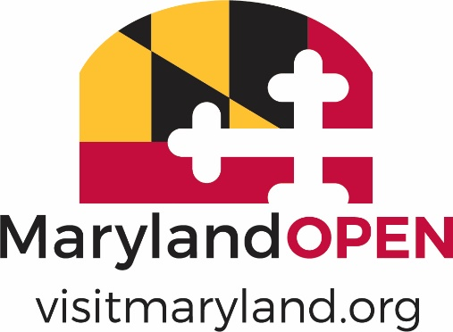

2021 MARYLAND TOURISM AWARDS

MARKET EXPANSION
NOMINATION FORM

Note: Eligible nominations must successfully offer a Maryland tourism product into a wider section of an existing market, or into a new demographic or geographic market.
Nominee Information:
Nomination Name:
Contact Name:
Mailing Address:
City/State: Zip:
Phone number:
E-mail:

Nominator Information (if different than above):
Name of Nominator:
Organization:
Mailing Address:
City/State: Zip:
Phone number:
Email:

NOTE: Please limit the information provided per description to 200 words or less and include quantifiable results when applicable.

- International, out of state and/or targeted demographic (30%)

- Creativity of the program – 25%

- ROI (cost of program in relation to attendance/visitor spend) - 25%

- Revenue generated (20%)

